EFD Filer View

Navigate to the website https://www.efdnasaa.org to begin.
This document shows filers the break-down of a filer account.
Contents:
Home Page 2
Login Screen 4
Accept Terms and Conditions 5
Home Screen Logged In 6
Regulator Home Links 6
Filers Home 7
Filers Home – Tools – Receipt Center 8
Filers Home – Tools – Cancelable Payments 9
Filers Home – Tools – Recent Activity 9
Form D – Deficient Notices 10
Associated Offerings 11
Form D – Draft Notices 11
Form D – Expiring Notices 12
Form D – Notice History 12
Form D – Active Notices 13
Form D – Inactive Notices 14
Form D Section – Withdrawn Notices 15
Form D Section – Terminated Notices 16
UIT Section – UIT Drafts 17
UIT Section – UIT Recent 18
UIT Section – UIT Configurations 19
UIT Section – Pre-Effective Notices 20
UIT Section – Actionable Notices 21
UIT Section – UIT Payment Carts 22
UIT Section – Deficient Notices 23
UIT Section – UIT Sponsors 23
UIT Section – UIT Notice Import 24
UIT Section – API Submissions 26
UFT Section – Search 27
UFT Section – Create New UFT Offering 27
UFT Section – UFT Carts 29
Franchise Section – New 29
Franchise Section – In Progress Filings 30
Franchise Section – Active Filings 30
Franchise Section – Inactive Filings 31
Franchise Section – Carts 31
Questions: 32

Home Page
This is the home page for the Electronic Filing Depository https://www.efdnasaa.org .
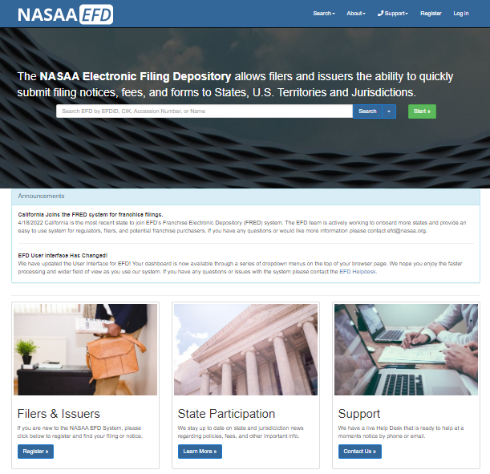
- If the filer does not yet already have a filer account, they must complete the registration steps in order to login
- If the filer has an account, they will click Log in at the top of the screen

Login Screen
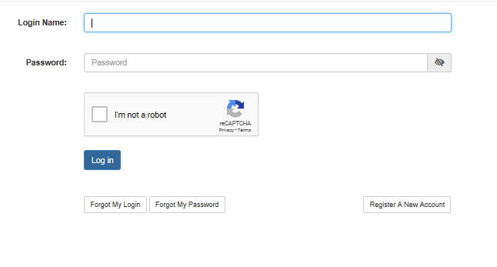
- Enter your Login Name
  - Your Login Name is not your email
  - Your Login Name IS NOT case sensitive
- Enter your Password
  - Your Password IS case sensitive
- Then click on the check box for reCAPTCHA
  - reCAPTCHA SHALL be filled out prior to login
- Forgot your Login or Password?
  - Use the option buttons at the bottom of this form to retrieve the lost Login Name and/ or reset the Password

Accept Terms and Conditions
Terms and Conditions must be accepted in order to successfully log into the EFD website. Rejecting the Terms and Conditions will result in you logging out. Click the Accept the Terms and Conditions button to continue into the EFD system. If your session is timed out, the user will be asked to accept the Terms and Conditions again upon logging in.
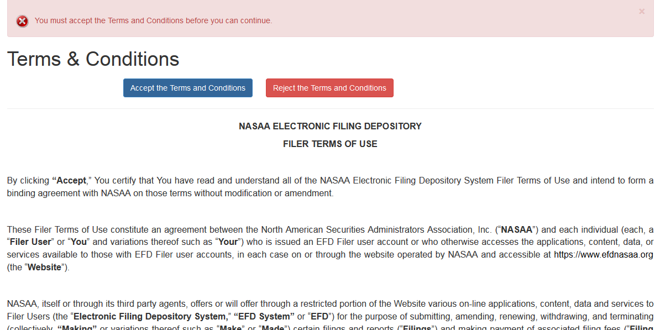

Home Screen Logged In
When logged in the Login Name/ Overview Name will show at the top right-hand side of the screen. 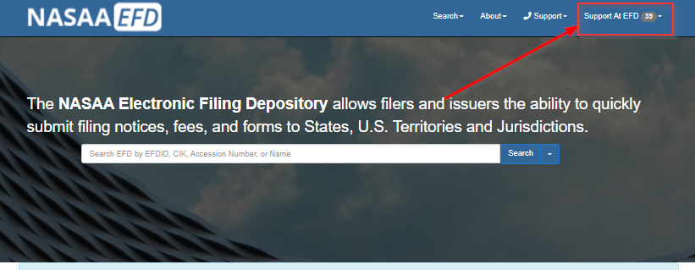

Regulator Home Links
If you wish to monitor your filings you will need to access the Filer Home Screen. You can get to the Filer Home Screen following any of the three options below (you must be logged in as a filer).
- Click on Login Name/Overview Name in the top right and Click Filer Home
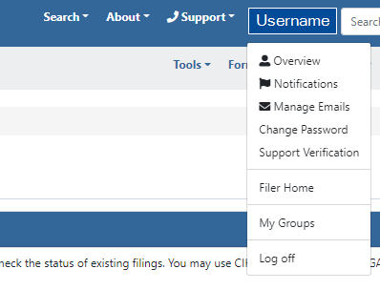
- Click on the Filer Home under Filers & Issuers
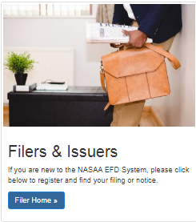
- Click on NASAA EFD in the top right hand corner

Filers Home
Welcome to the Filers Home page– it is comprised of Welcome Filer Tips/videos, Release Notes/Announcements, and the Filers Home Tool Bar.
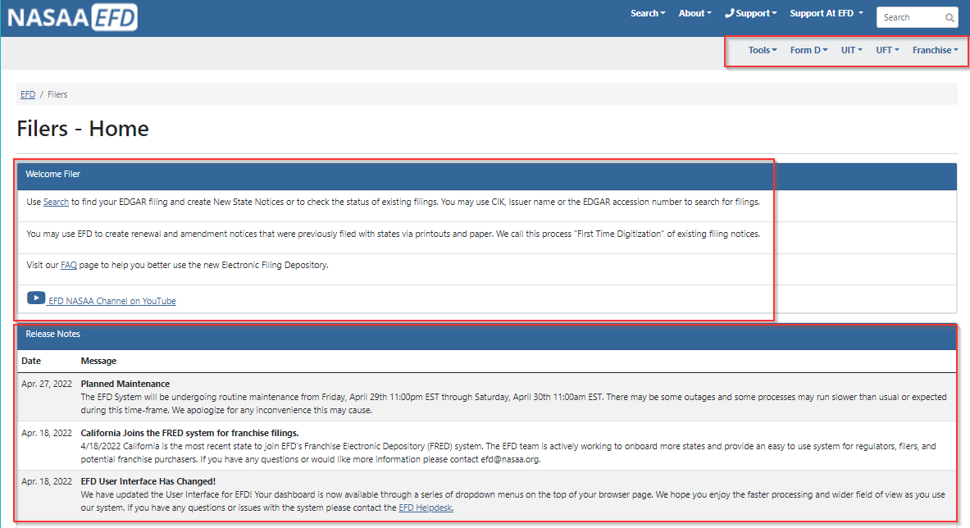

Filers Home – Tools – Receipt Center
This center allows you to see all the receipts you have made and if you’re associated to a firm group and have the access to see group notices, group drafts, and can pay you will see other filer’s receipts in your group.
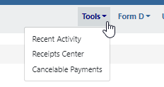
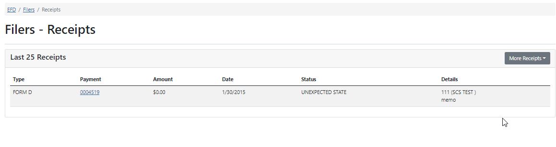

Filers Home – Tools – Cancelable Payments
This section allows filers to cancel a payment made same day up until 3pm EST. If the filer made the payment after 3pm EST, it’s available to cancel until next business day of 3pm EST. When a payment is canceled the associated filing is canceled and turned back into a draft. The draft is dropped into draft notices
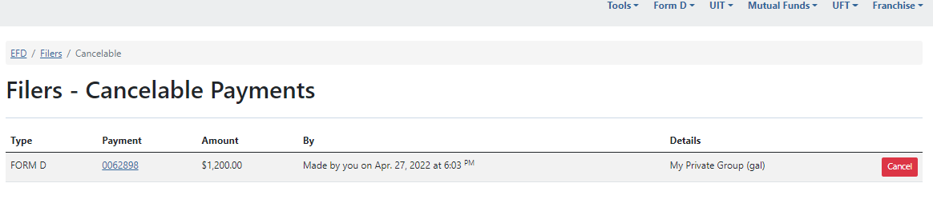

Filers Home – Tools – Recent Activity
This section is for recording user activity and system click to click history. This activity is really for support to troubleshoot issues/bugs you may be experiencing.

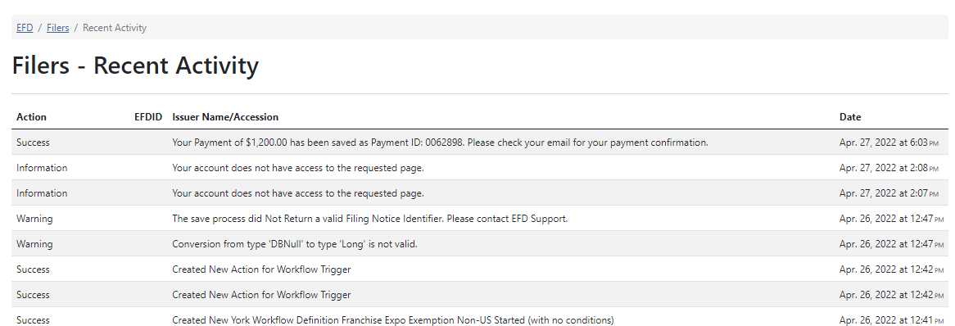

Form D – Deficient Notices
This sub section allows filers to manage keep track of known State, expiration, and payment deficiencies. State level deficiencies usually come with a comment instructing you to do something or stating what’s wrong with the filing. Payment deficiencies can be resolved and turned into drafts for resubmission.
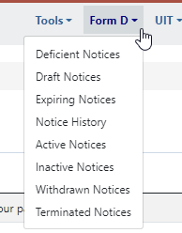
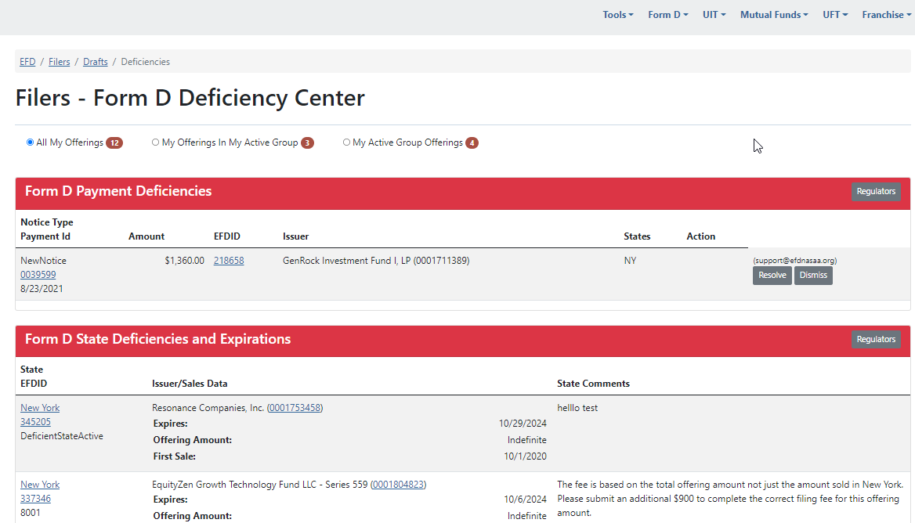

Associated Offerings
At the top of most your pages in the Filer Home you have three bubbles with numbers next to them. These change your view based on access and association. For example, let’s say that you made a filing using a different group or that someone in your group made a filing/draft and you want to see it status.
- Select All My Offerings to see offering from all your groups.
- Select My Offerings in My Active Group to see only the offerings in your current group.
- Select My Active Group Offerings to see all the offerings from everyone in the active group.

Form D – Draft Notices
This Section stores all unpaid/unsubmitted filings “Drafts” for the filer automatically. Filers can continue to edit a draft, delete drafts, and print out an Estimated Charges document to provide to the issuer before paying. Filers also have the ability to click on “PayNow” to proceed to the ACH payment screen if they have already reached the Confirm Details page.
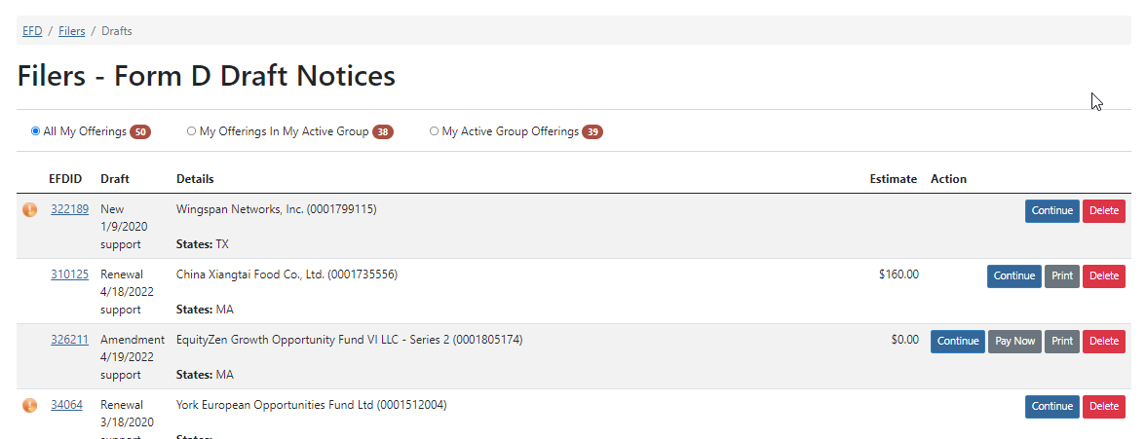

Form D – Expiring Notices
This section shows notifications of when notices will expire by a set date. Clicking “View” will take the filer to the View Filing Notices page so they can click on “Add Notice” to Renew, New Notice, or Terminate.
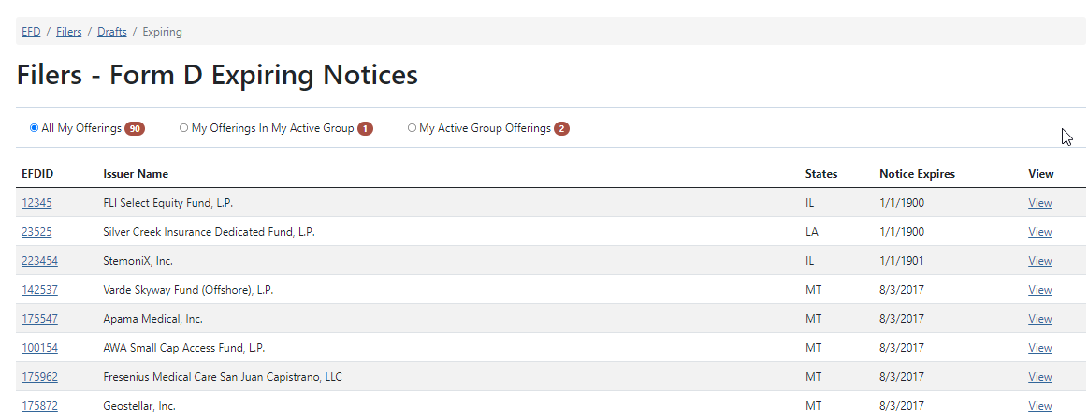

Form D – Notice History
This section allows you to search the notice status, payment, and regulator comment history of a FORM D notice filing. When you do a search in Notice History results of offerings will appear from EFD. When you see your offering click on View to go to the History.
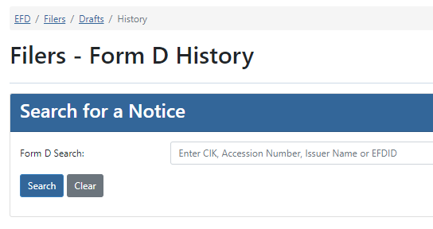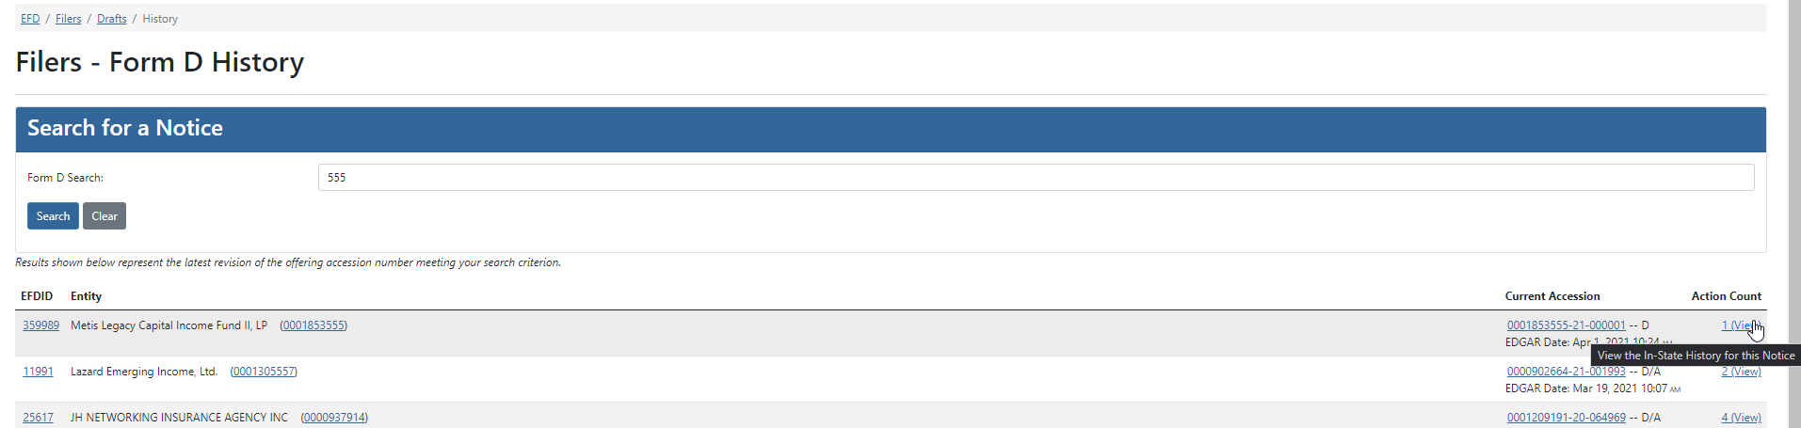

Form D – Active Notices
The Active Notices shows the filer’s state notices currently ACTIVE in EFD. Using search criteria, you can filter among all the Active Notices. Click the down arrow next to an issuer to see all offerings and state notices related.
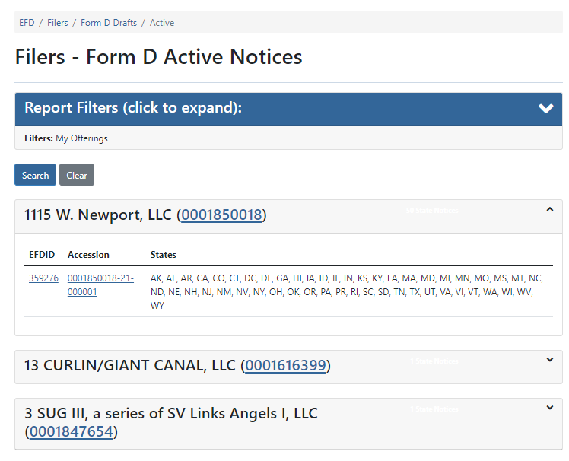

Form D – Inactive Notices
Inactive Notices lists all the notices that are currently Inactive under the filers account. The filer can generate an Excel Spread sheet to look over this.
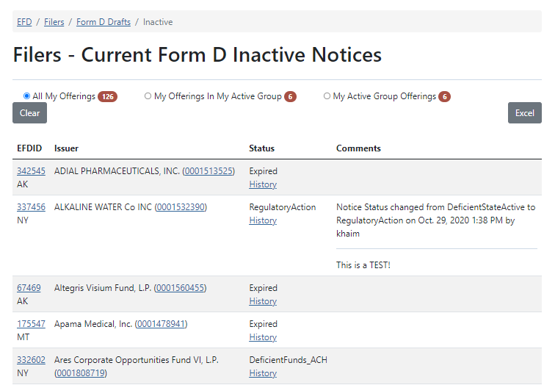

Form D Section – Withdrawn Notices
This section lists all notices between a set period that have been withdrawn.
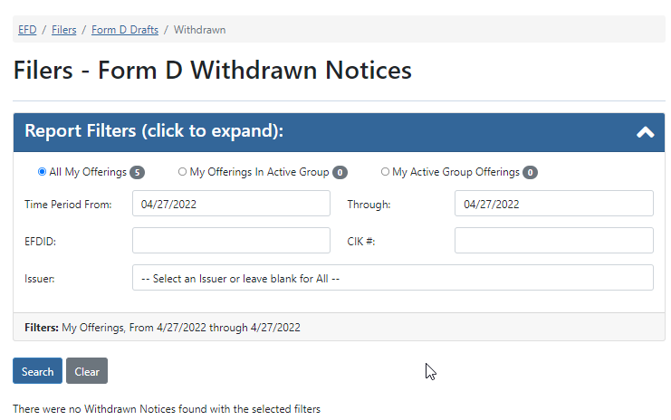

Form D Section – Terminated Notices
This section lists all notices between a set period that have been terminated.
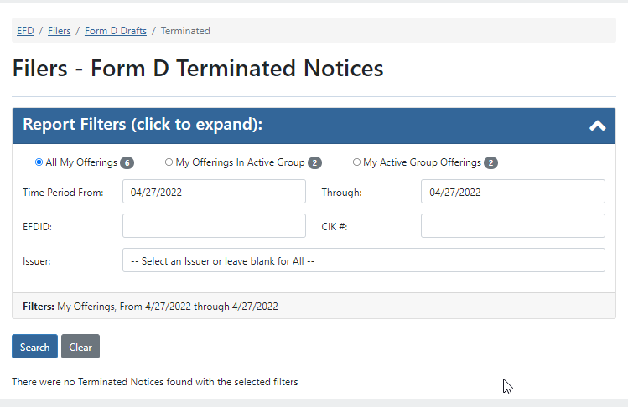

UIT Section – UIT Drafts
The UIT Draft section shows filers all the configurations for UIT that have states drafted and ready to pay or had states drafted and prepared to pay.
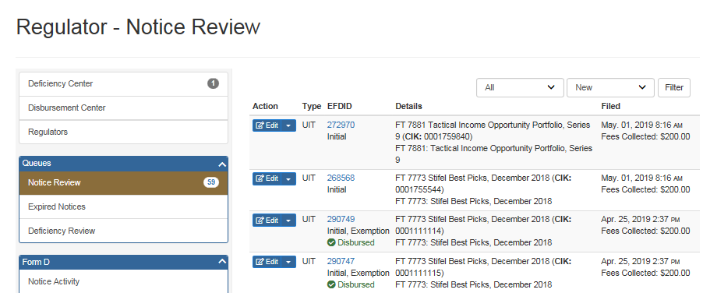

UIT Section – UIT Recent
This section shows the filer the recently edited configurations in chronological order from newest at top to oldest going down. Clicking “Start New Configuration” will allow the filer to create a new trust configuration. Upload Excel will redirect the filer to the UIT Notice Import page. Clicking the document to the right will allow you to download the configuration into an importable excel file.
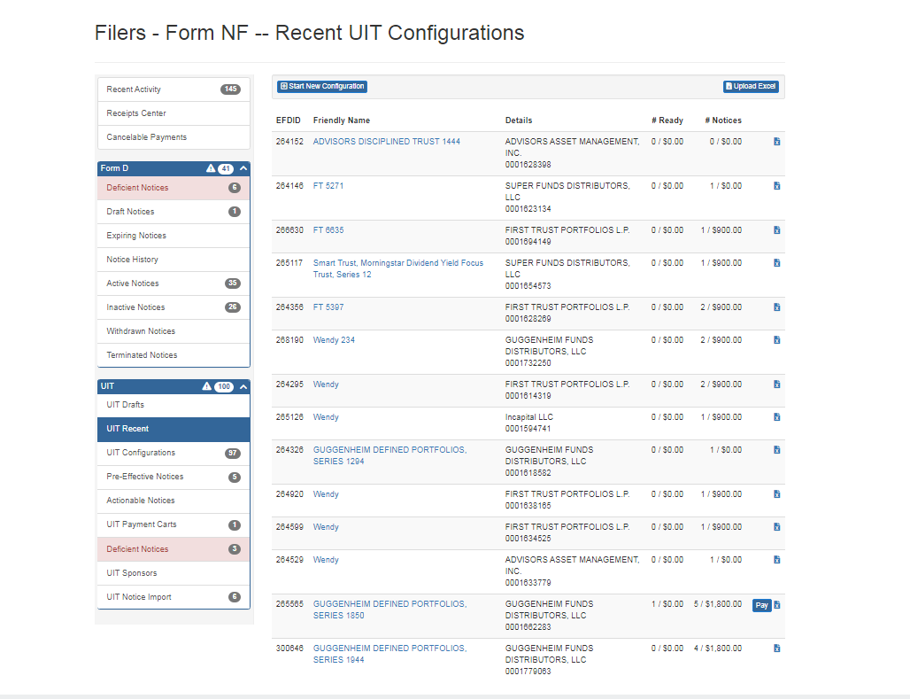

UIT Section – UIT Configurations
The UIT Configuration section lists all known Configurations associated with the filer. This screen layout is similar to UIT Drafts and UIT recent.

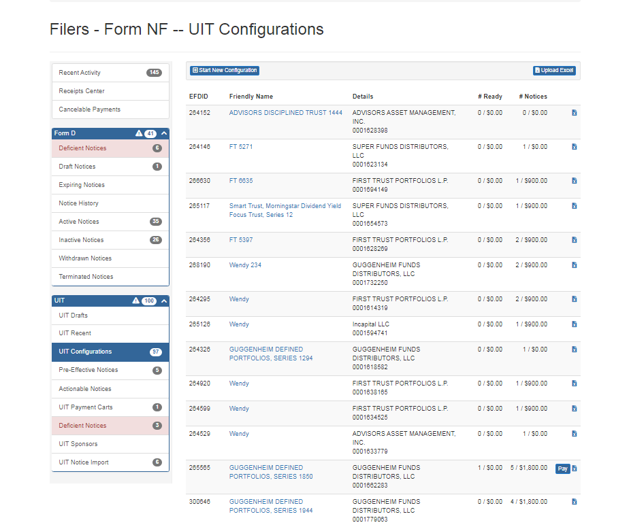

UIT Section – Pre-Effective Notices
This section allows the filer to review and update the SEC Effect dates and date ranges for all Pre-Effective notices made by that filer. After checking off the items the filer wishes to make effective they will provide the effect date below. The filer can make the state filing effective Now, On Provided Date, or On Filed-On Date.

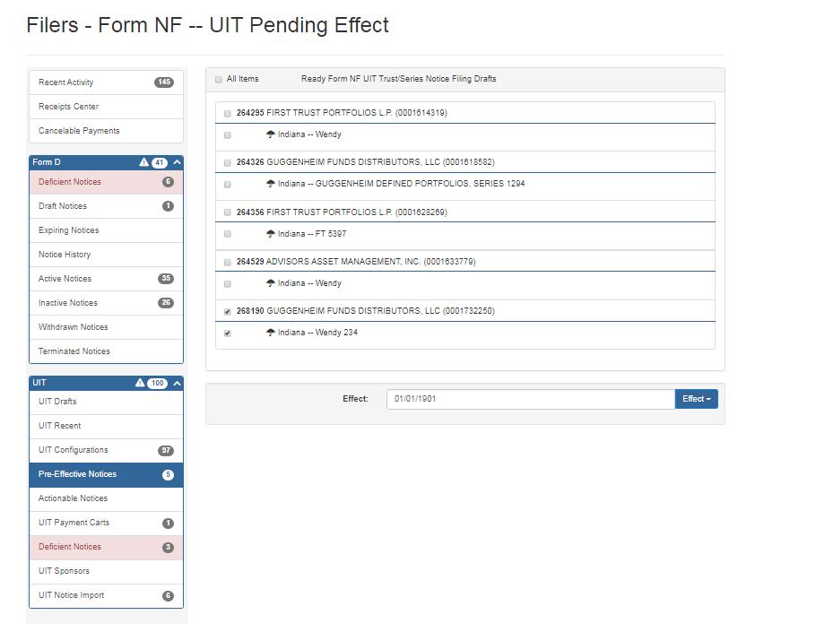

UIT Section – Actionable Notices
This section informs the filer of any additional requirements or missing information needed. For example, if the state requires a sales report on filing a renewal and the filer failed to provide the sales report it will flag It here.

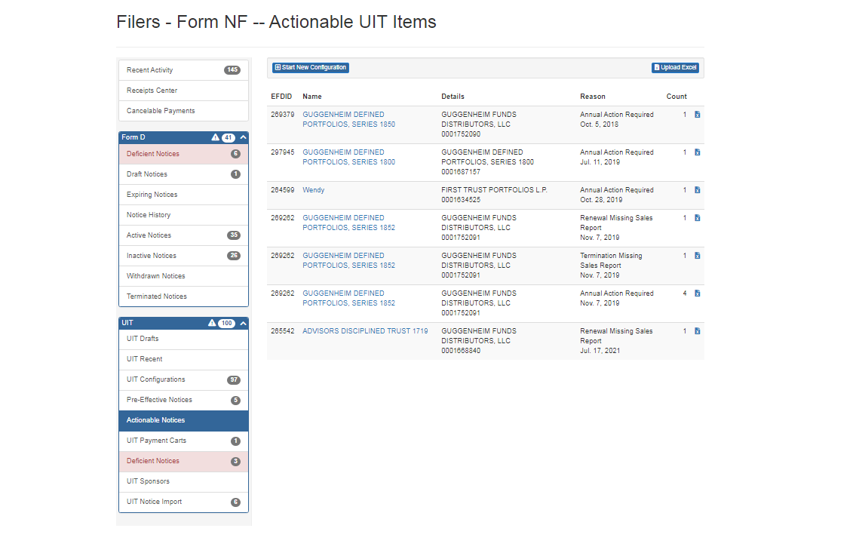

UIT Section – UIT Payment Carts
The UIT Payment Carts is designed to allow filers to create individual carts and pay separately or merge together existing “carts” and pay all together.

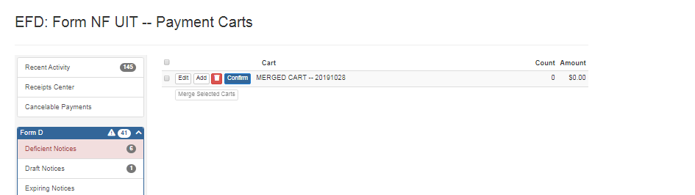

UIT Section – Deficient Notices
This section will show current state deficiencies, payment deficiencies and expired state notices for UIT. A link to the UIT Regulator Contacts is provided in the upper right hand corner for convenience.
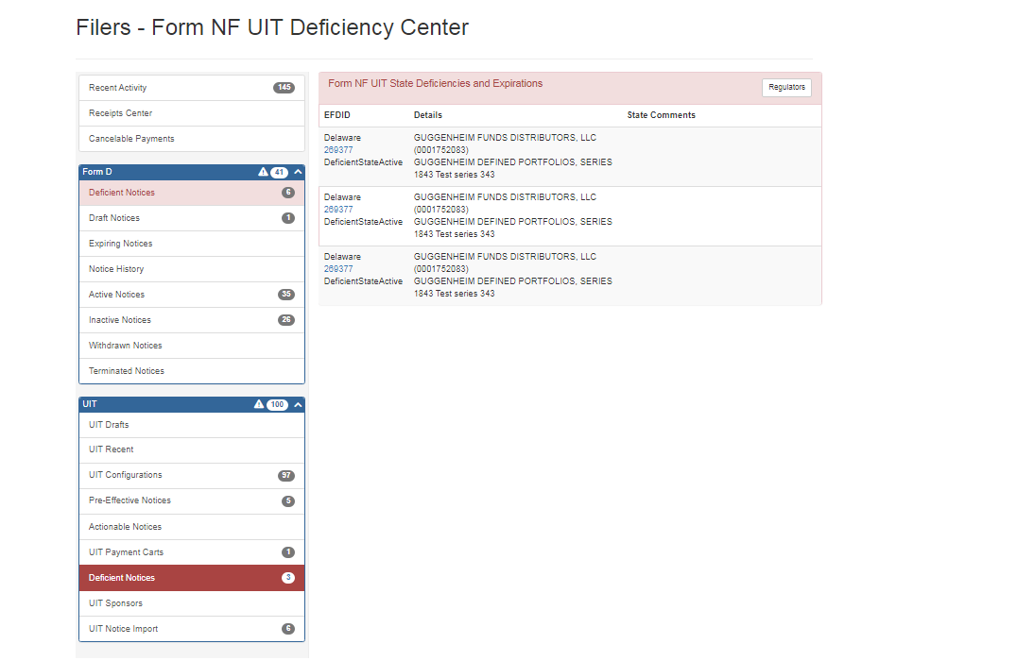

UIT Section – UIT Sponsors
This section allows filers to add and save sponsors. You can edit existing sponsors to update the name and offering amount information.
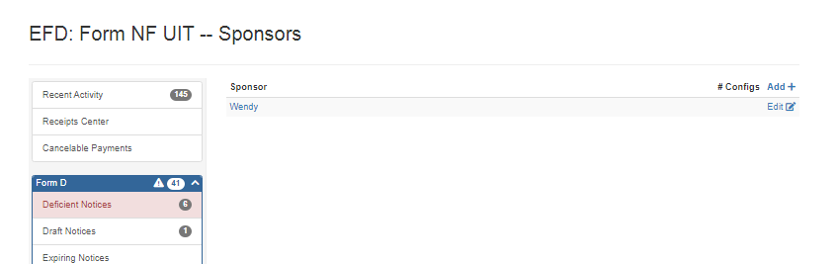
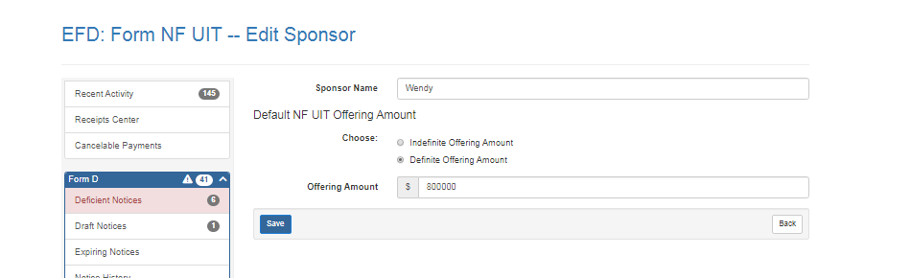

UIT Section – UIT Notice Import
The UIT File Upload or Notice Import page allows a UIT filer to fill out one of our blank Excel documents with UIT filing info and upload it. This allows filers to import large amounts of notice filings/ series/ and even multiple trusts. When you upload an Excel document you will be required to accept and agree with the U2 Uniform Consent to Service of Process, Mark all uploaded items as ready and sign a signature and provide the title. After this is done you can associate the notice(s) to a group. When ready you will click on the Browse button to search your system for the file to upload. If there is an issue with the Excel document an error message will state what is wrong on the document.

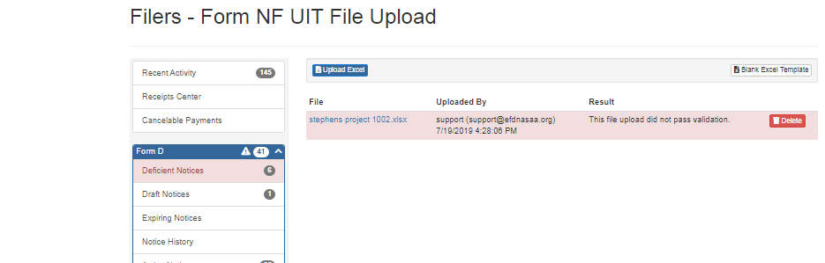
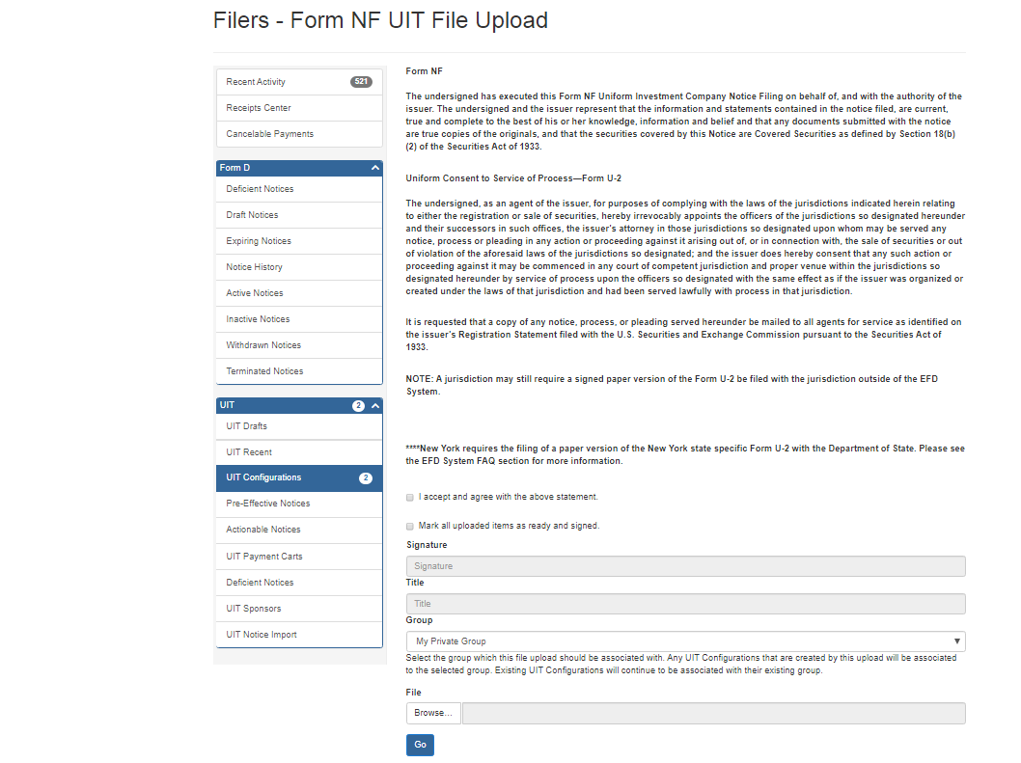
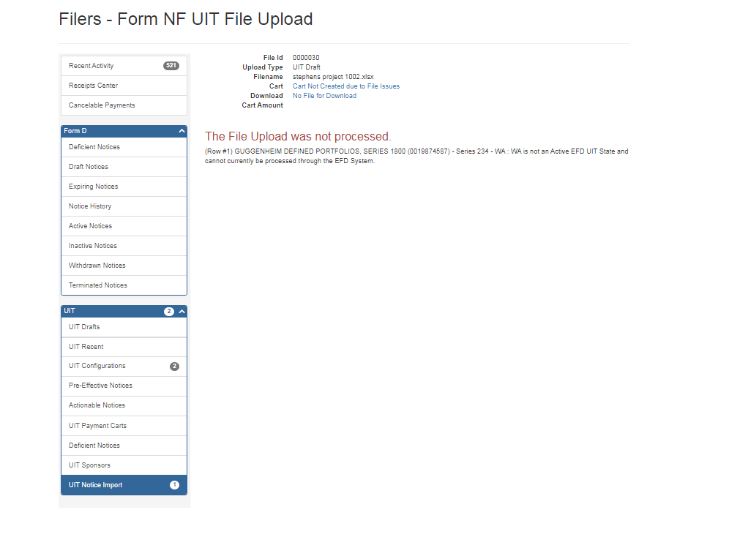

UIT Section – API Submissions
This page is for looking at the UIT submissions you submitted through the API into EFD.
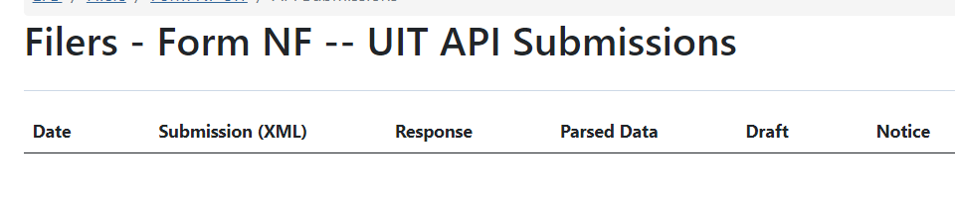

UFT Section – Search
This search page can only be accessed from the UFT drop down in the FILERS HOME page.
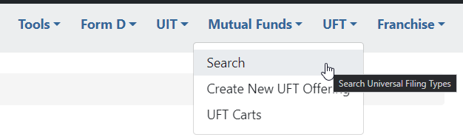
If you know the EFDID number or name of Submission you can search for your UFT here.
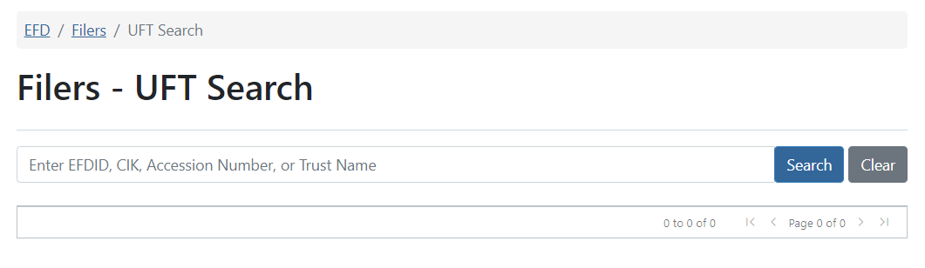

UFT Section – Create New UFT Offering

The purpose for this page is to create a UFT offering so you may submit your state filings and materials to the states. You also have the ability to send fees to states.
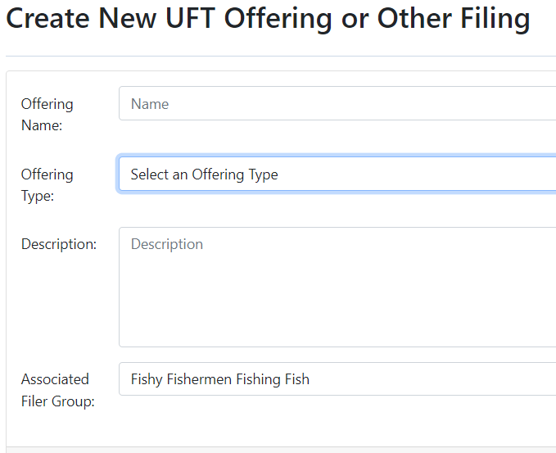
You must provide the name of the offering. Next, the filer must select from the list below for an offering type.
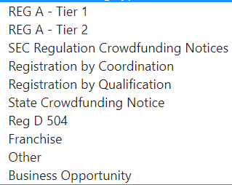
Filer/Issuer will then provide a description of the offering (what is it for?).
Then you will provide what group the filing is being associated with. Clicking “NEXT” will start the UFT filing process.

UFT Section – UFT Carts
This page is responsible for storing unpaid UFT carts or in progress UFT carts.
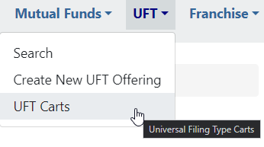
The filer/Issuer has the ability to edit the cart details by clicking on “Edit”. You can delete the cart if you click on the red “TrashCanSign”. If the filer needs to return to the payment page they can click “Continue” on this page.
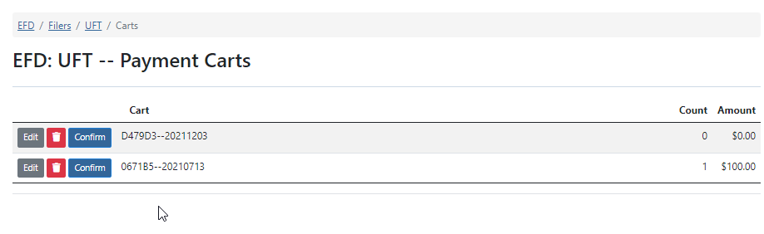

Franchise Section – New
The “NEW” option in the Franchise drop down allows you to create a new Franchise filing or search for an existing one.
The “Enter Franchise Name” search box will look up existing franchises that are similar to the name you provided. If you are provided a result you can click on the EFDID and see what has been filed to see if this is the franchise you need to file for. If it is not the franchise you are looking for you can click on “Start New” or “Enter Franchise Details” This begins the Franchise filing process.
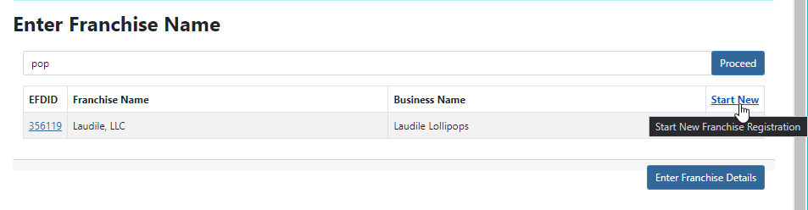

Franchise Section – In Progress Filings
This section shows all the Franchise filings you have ownership of and/or working on. This is the section you go to add application(s) onto your franchise filing(s). The In Progress Filings page provides the outstanding open requests/ status and a warning if the franchise is about to expire or has expired per franchise.
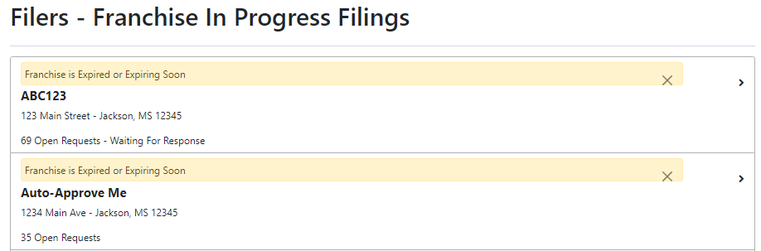

Franchise Section – Active Filings
The Active Filings section shows a list of franchises that have Active state filings. You can review the applications by clicking on the franchise of choice.
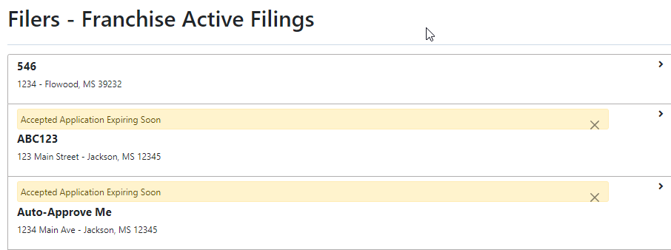

Franchise Section – Inactive Filings
The Inactive Filings section shows a list of franchises that have Inactive state filings. You can review the applications by clicking on the franchise of choice.
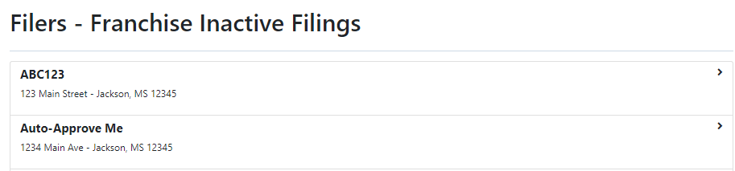

Franchise Section – Carts
This page is responsible for storing unpaid Franchise carts or in progress Franchise carts.
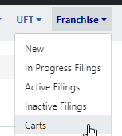
The filer/Issuer has the ability to edit the cart details by clicking on “Edit”. You can delete the cart if you click on the red “TrashCanSign”. If the filer needs to return to the payment page they can click “Continue” on this page.
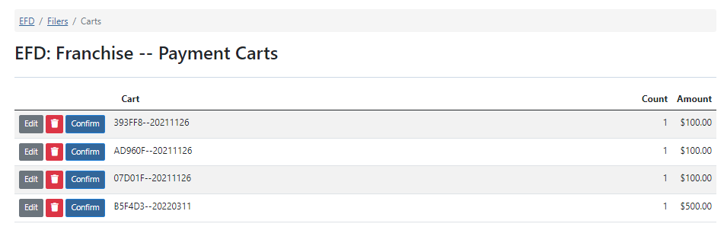
Questions:

NASAA EFD Support
601-453-1979
support@efdnasaa.org
Support Hours
9 AM EST – 6 PM EST
Excluding National Holidays

