EFD Filer Registration
This document will take you step by step through the filer registration process.

Contents:
Screen: Home page 2
Screen: Choose Account Type 3
Screen: Filer Registration 3
Screen: Registration Account Validation 4
Screen: Manage Your Filer Profile 5
Screen: Change Password 7
Screen: Login 8
Screen: Forgot Username 9
Screen: Forgot Password 9
Additional Help Available: 11
Questions: 11

Navigate to https://www.efdnasaa.org to begin.

Screen: Home page
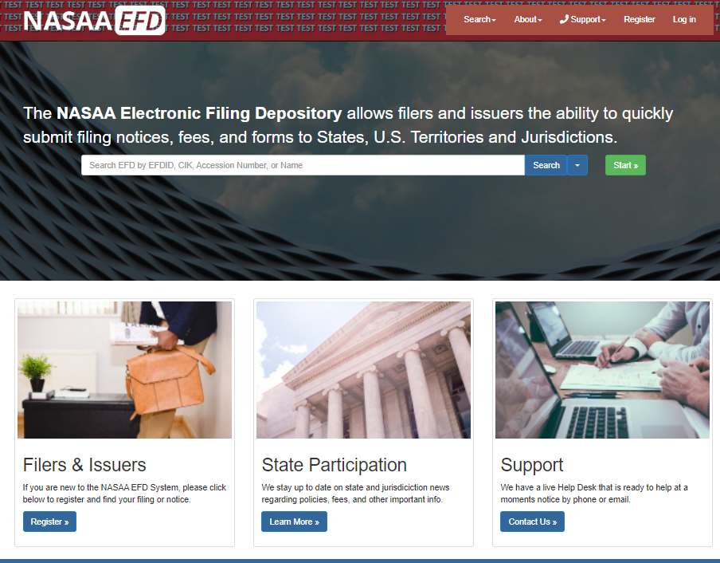
This is the home page for the Electronic Filing Depository. If you already have an account with EFD, then you may login with your existing username and password.
To register a new Filer account with EFD, proceed with the following steps.
Click Register at the top of the screen or the Register link under Filers and Issuers.

Screen: Choose Account Type
After clicking Register at the top of the screen you are asked to select the type of account you want to create. Regulators accounts are limited to regulators in U.S. Jurisdictions.
Click Register under Filers.
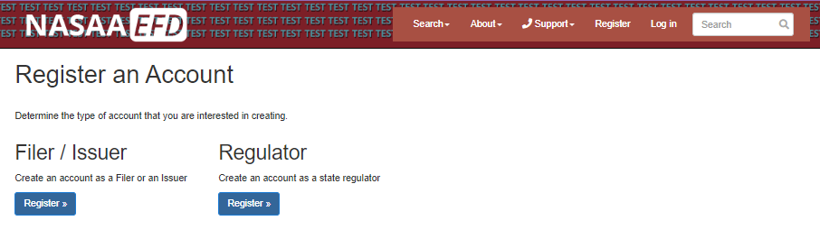

Screen: Filer Registration
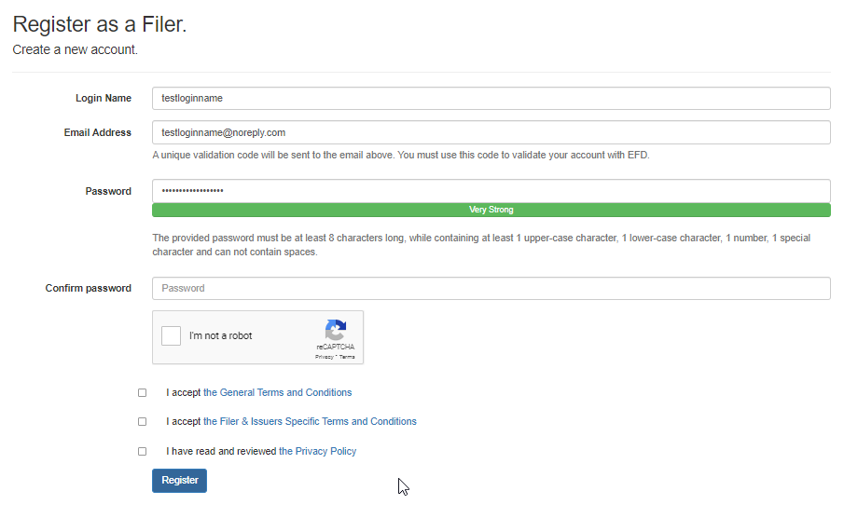
Fill in registration form with a Login Name, Email Address and a Password. You must also enter the text shown in the CAPTCHA field.
Rules:
- Only letters and numbers are allowed in user names. No Special Characters
- Password Strength must be strong.
- Passwords must use special characters (special character cannot be the first character), numbers, and lower and upper case characters.
- You must accept the Terms and Conditions.
- You must accept the Privacy Policy.
Input Validation:
- You will be warned with a message at the top of the screen if your registration input is not valid based on the rules described above.
Result of clicking register:
- EFD will send a Registration Validation email to the email address you provided containing a unique validation code.
Example: 9f2c025876ef4125b989ca3fa7626ecb

Screen: Registration Account Validation
You may validate your account by:
- Clicking the URL provided in your Registration Validation email that contained the validation code, or
- Go to www.efdnasaa.org and enter the username and password you entered during the registration process, and
  - Enter the validation code from the Registration Validation email,
  - Accept the Terms and Conditions, and
  - Click the Validate button.

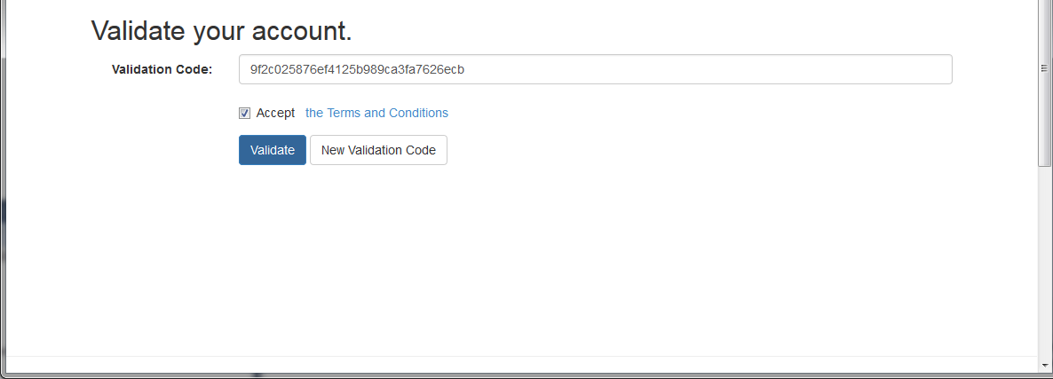
You may click the New Validation Code button to send a new validation code to the email address provided during the registration process.

Screen: Manage Your Filer Profile
Click the name in the top right hand corner of the screen to access your Account Options.
Click the Overview option to access your profile information and home screen of your Account Options.

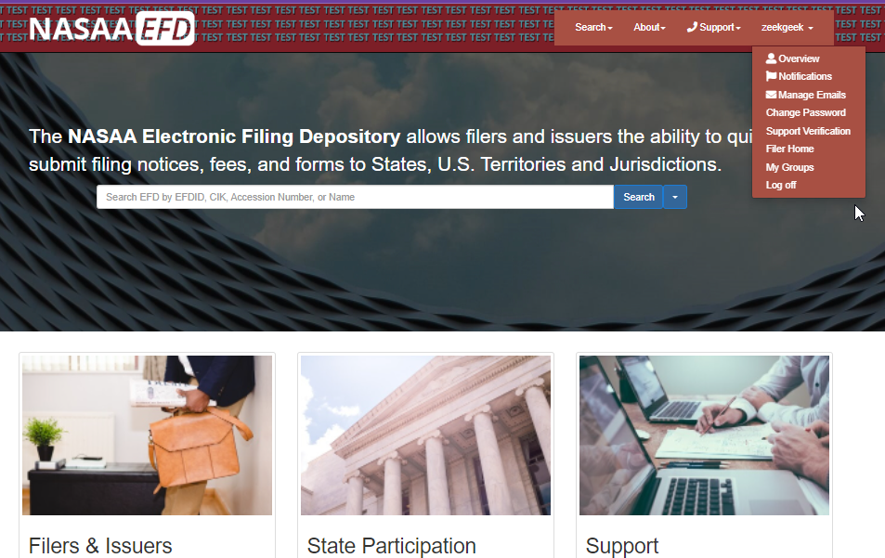

Fill in the information on the Manage Your Profile screen. Items in red need to be completed. Click the Save Changes button at the bottom of the screen to save any changes to your profile.
EFD will generate an email acknowledging that changes have been made to your profile.
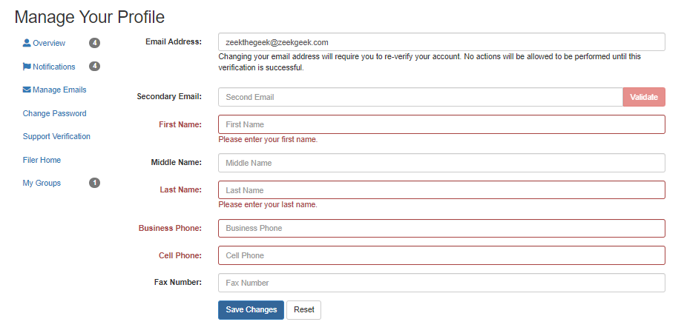
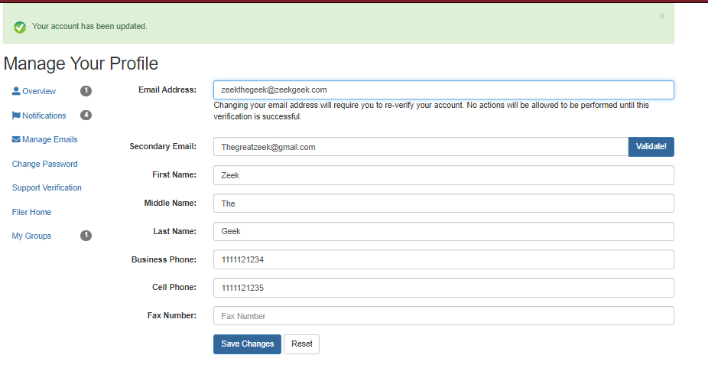

Screen: Change Password
On the Account Options page, click the Change Password button on the left side of the screen.
Enter your current password and your new password into the appropriate text input boxes.
Click the Change Password button.
EFD will generate an email acknowledging this action.
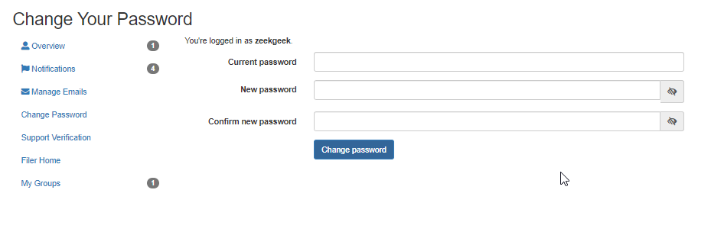

Screen: Login
From the EFD homepage, click the Log In button at the top of the screen.
Enter your Login Name, Password and type the CAPTCHA.
Login Name IS NOT case sensitive.
Password IS case sensitive.
CAPTCHA IS NOT case sensitive
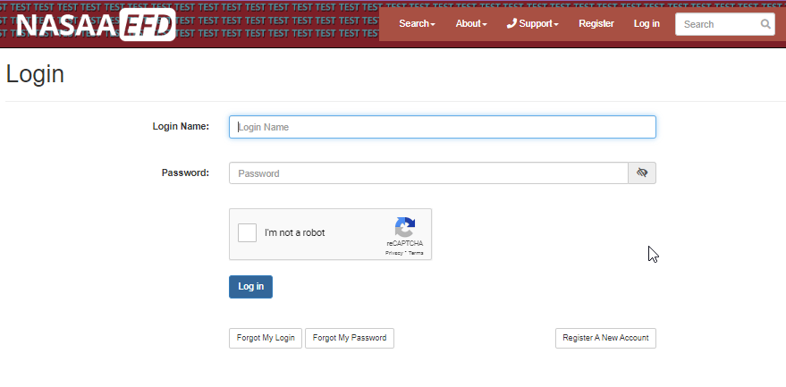

Screen: Forgot Username
Use this tool to have your username sent to your email address. This tool will neither confirm nor deny that an email address exists in the EFD system. It simply accepts the input of an email. If the email address does exist in EFD, an email is sent to that email address. If the email does not exist in EFD, then the system will do nothing.

From the EFD homepage, click the Log In button at the top of the screen, then click the Forgot My Login button.
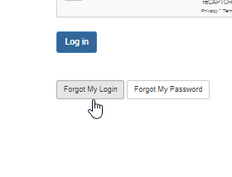
Enter your email address and click Submit.
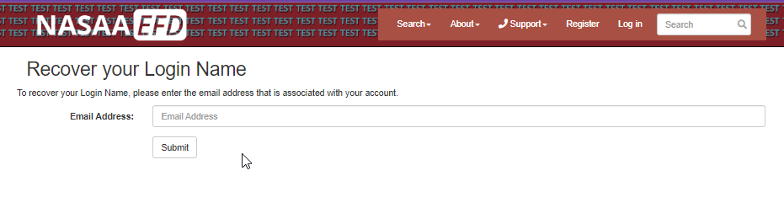

Screen: Forgot Password
Use this tool to reset your password. You must enter the correct username and email address combination. The EFD system will neither confirm nor deny the existence of either username or password within the EFD. If the correct combination is entered, an email is generated with password reset instructions.
From the EFD homepage, click the Log In button at the top of the screen, then click the Forgot My Password button.
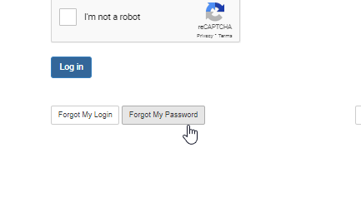

Enter your Login Name and Email Address and click Submit.
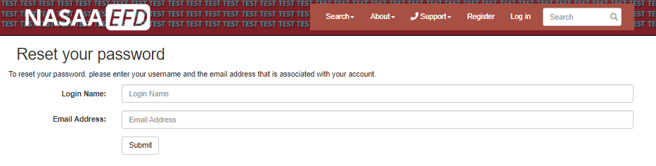
You will receive an email from EFD containing a temporary password. Once you login you will need to perform a Change Password.

Additional Help Available:

http://www.efdnasaa.org/DOCUMENTATION/FILERS/FormDCreateNotice.DOCX

Questions:

NASAA EFD Support
601-453-1979
support@efdnasaa.org
Support Hours:
Monday - Friday
9 am EST – 6 pm EST
Excluding National Holidays

